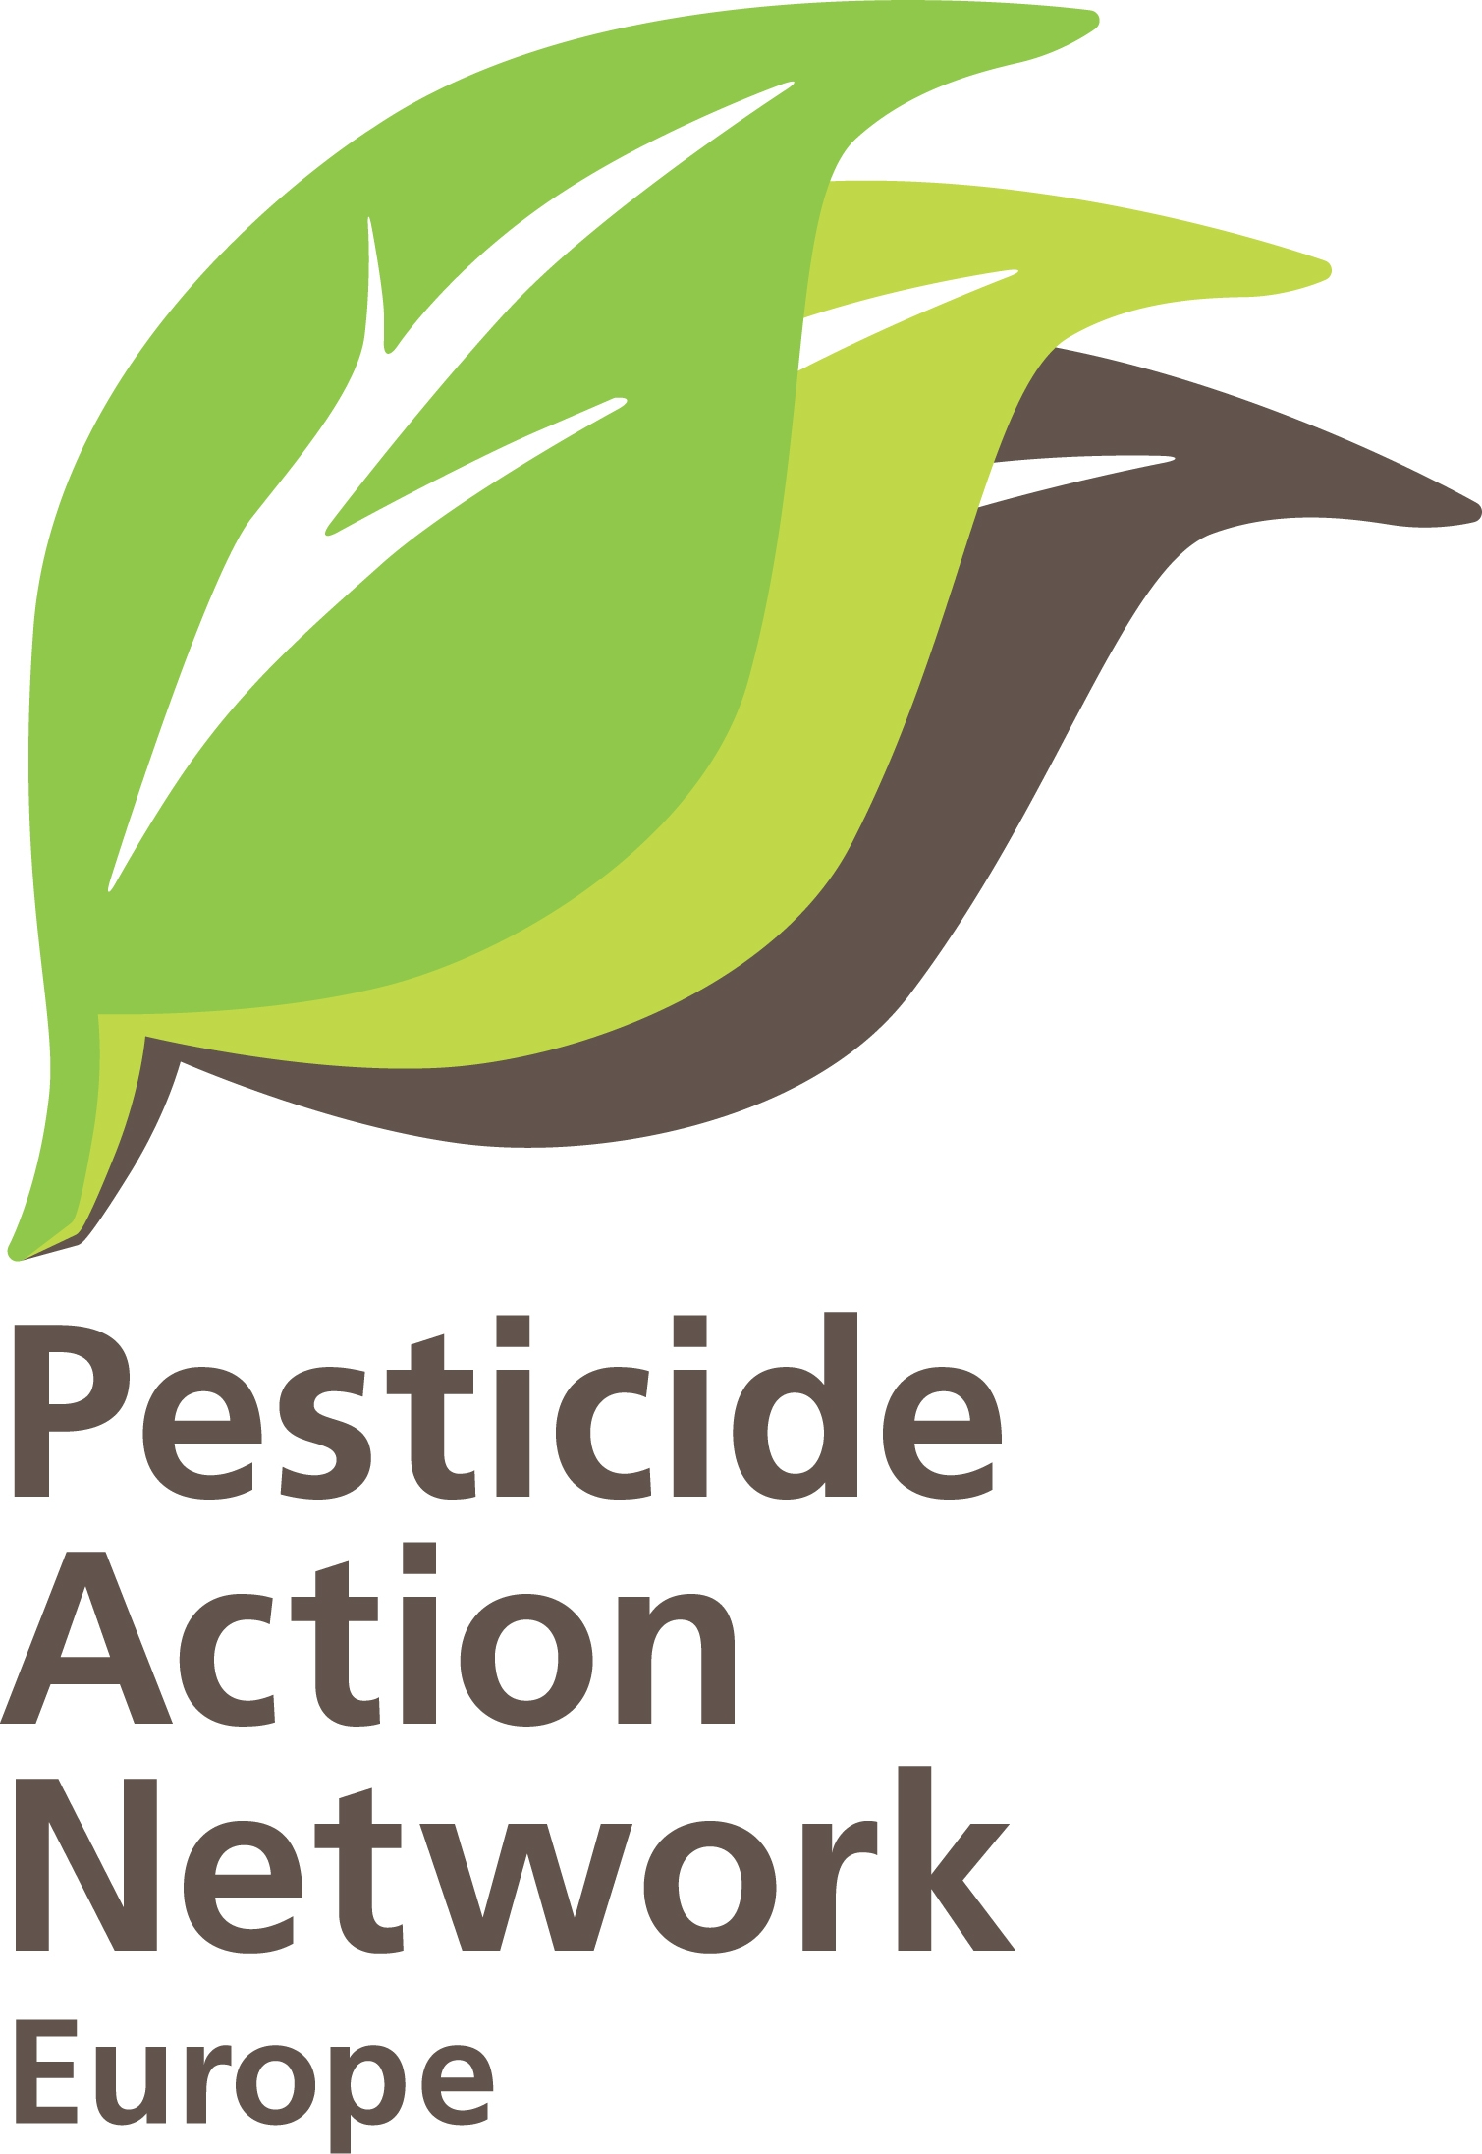 | PRESS RELEASE  Brussels, 20-10-10,  PAN-Europe  Info : Hans Muilerman,  tel. 00316-55807255

EFSA undermines pesticides Regulation on use of science.

Today Belgium Presidency organises an international Round Table on the use of science in food policy thereby given EFSA the floor as key speaker. PAN-Europe is questioning the role of EFSA in the use of science. In a recent draft text of EFSA on the use of science in pesticides policy, EFSA puts tests of chemical industry on a platform and proposes to keep independent academic science at a distance. Work of highly qualified independent scientists at academia will continued to be denied in Brussels decision-making if EFSA gets its way, while industry tests of generally unknown quality and reliability remain the main source of ‘science’ in Europe’s decision machine for protecting health of its citizens and the environment.

In recent pesticide regulation 1107/2009 the Union decided “scientific peer-reviewed open literature” should be taken into account from now on. Clearly the Union didn’t want to rely only on industry tests anymore as it did in the past. EFSA performs the role of making a guideline for this provision. In its draft guideline EFSA proposes to let industry do the search and evaluation of the scientific literature and allow such narrow search-terms (basically only tests similar to standard industry tests) that it is clear academic science will keep on being denied. It is like asking a butcher to test the quality if its own meat as well as selecting and testing the meat of the other butchers in town. The outcome cannot be a surprise. EFSA clearly undermines a democratic decision to take independent literature into account. EFSA even redefines the provision to only “scientific literature”.
PAN-Europe send her feedback on the EFSA proposal as part of a public consultation and requests Commission, Council and Parliament to deny this guideline. Letters to Commissioners have been send already.

It is a big question mark why EFSA has so much trust in industry tests and so little in the academic world. In the past several cases of fraud in industry testing were uncovered, so a balance with independent literature seems very relevant. PAN-Europe will do a request for access to documents to find out what happened in EFSA.

Suggested citation: European Food Safety Authority; Submission of scientific peer-reviewed open literature for the approval of pesticide active substances under Regulation (EC) No 1107/2009 (OJ L309/1, 21.10.2009, p. 1). EFSA Journal 20xx; volume(issue):xxxx. [40 pp.]. doi:10.2903/j.efsa.20NN.NNNN. Available online: www.efsa.europa.eu
On request we will send our comments on the EFSA guidance (hans@pan-europe.info)

